Week Ending: | DAY: |  |  |  | Subject: Creative Arts
Duration: |  |  |  |  | Strand: Visual Arts & Performing Arts
Class: B3 | Class Size: |  |  |  | Sub Strand: Planning, Making and Composing
Content Standard:  Demonstrate understanding of how to generate own ideas for artistic expressions on the people, based on their history and culture, the environment and the topical local/national/global issues. |  |  | Indicator:  B3.1.2.2 /B3.1.2.3 create own functional artworks by skilfully using available arts tools and material. |  |  | Lesson:  1 OF 1
Performance Indicator:  - Learners can create own functional artworks by skilfully using available arts tools and material. |  |  |  | Core Competencies:  Decision Making Creativity, Innovation Communication Collaboration Digital Literacy
Teaching/ Learning Resources |  | Photos, videos, art paper, colors and traditional art tools, other materials available in the community.
References: Creative Arts Curriculum Pg. 68
DAYS | PHASE 1: STARTER | PHASE 2: MAIN | PHASE 3: REFLECTION
 | Activate the previous knowledge of the learners by making them answer questions on the previous lesson.  Engage learners to play games and sing songs to begin the lesson  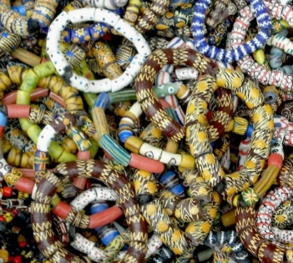 | Engage learners to make a simple beadwork using materials in the local community.  Learners gather materials and tools available in their community.  Demonstrate and guide learners to make a simple beadwork.  Allow learners to practice in groups following the steps provided  Learners to discuss and compare their artworks to the artworks studied. | Use questions to review their understanding of the lesson  Ask learners to summarize what they have learnt
 | Show learners a video or pictures of the dance you want to teach.  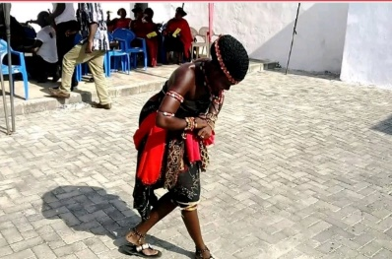 | In our last performing arts lesson, we learnt how to create our own dance moves.  Guide learners to pick a piece of music for the dance.  e.g. Adowa dance  Guide learners to determine the style and plan for the dance.  Show learners a video or pictures of the dance.  Demonstrate the dance moves to learners as they observe.  Have learners practice the moves in a formation dance | Use questions to review their understanding of the lesson  Ask learners to summarize what they have learnt

